**Lab Exercise**

**Question**

1. When select / add image. you want the image in what position?

- is the image stack to each other’s?

- is the first select image on top, then continue the second image?  
- Need to put all teammates animals, flowers?

**Problems:**

Image A

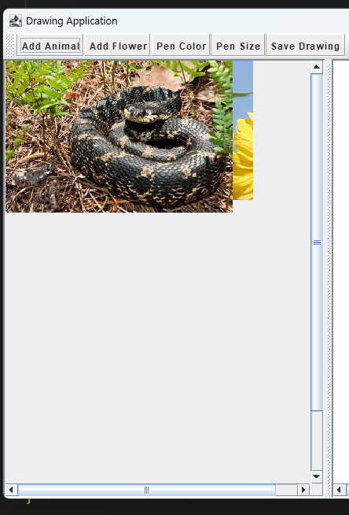



Image B

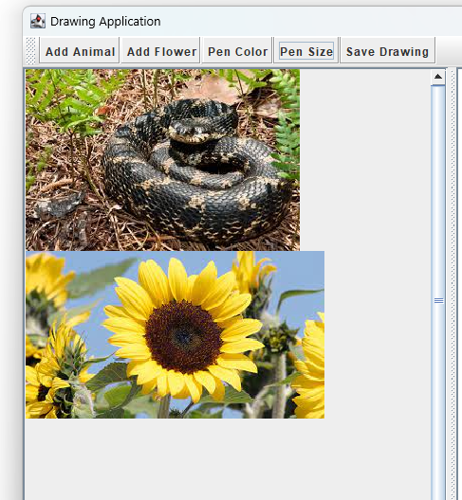



Image C

Image D

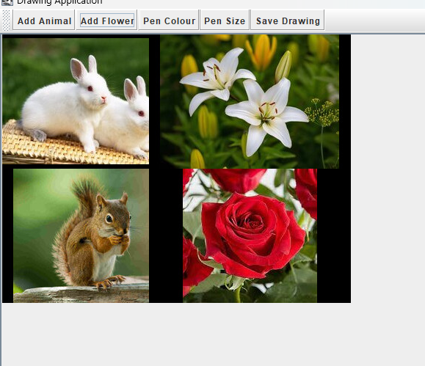



**Question**

1. . Any creation image will be able to rotate. The left canvas also can be rotated. Both canvas and creation images can be rotated independently

**Problems:**

- The image needs to rotate 360’/ 180’ / 45’ degree?

- when it rotates the image in same position or change position?

|  |
| --- |
|  |

UML Diagram

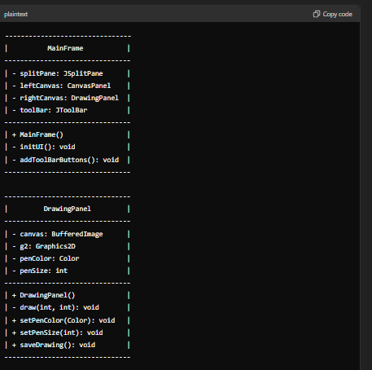

Sequence diagram

